What is Cloud?

* There is no cloud, it’s just someone else’s computer.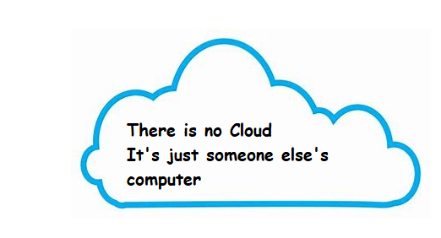
* Important Terms in Cloud
  + Cloud Services Provider (CSP):
    - CSP is the owner of physical hardware on which we create virtual infrastructure (compute, storage, memory, network)
    - Examples: AWS, Azure, GCP, AliCloud
  + Cloud Services Consumer (CSC):
    - This is typically an organization which uses services offered by CSP
  + Service:
    - CSP will provide different options to create virtual infrastructure for meeting your application needs, these are referred as *Services*
  + Resource:
    - Using Services offered by CSP, we create virtual infra for applications which is referred as *Resources*
* Any Cloud should have the following characteristics
  + On-demand Self-service
  + Broad Network Access
  + Rapid elasticity
  + Measured Service
  + Resource Pooling
* Cloud is categorized into following deployment models
  + Private Cloud: Used by specific organizations, but can be managed by third parties 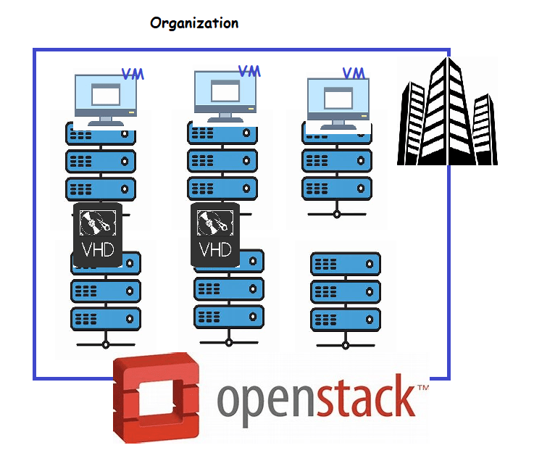
  + Public Cloud 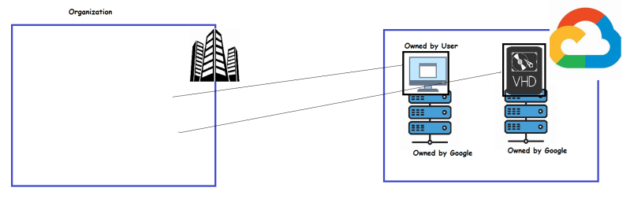
  + Hybrid Cloud: Composed of public cloud or private cloud or on-premises infrastructure
  + Community Cloud: Used by specific communities Eg: Gov Cloud, Health Care Cloud

Google Global Infrastructure

* GCP has a global footprint. 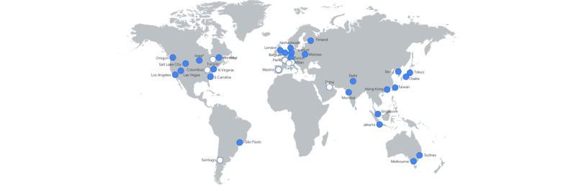
* A *region* in GCP is an independent geographic location.
* A *zone* is a deployment area for GCP resource. Zone corresponds to multiple datacenters in multiple buildings located in the same site 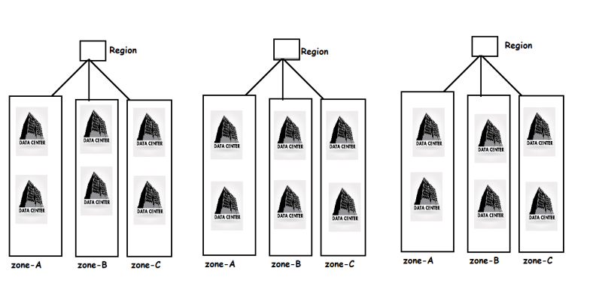
* A Global Network: Google cloud has a high speed fibre network which connects every region and edge location
* This network will help in communication from one region to other region which happens over the global network of google cloud 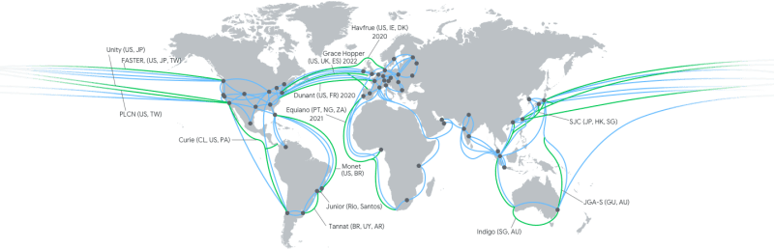
* Network Edge Location:
  + Connections to GCP Services located in particular metropolitan area 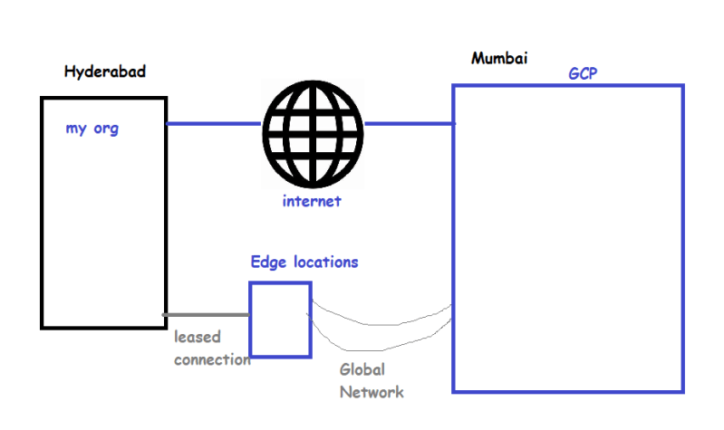
  + Content Delivery Networks 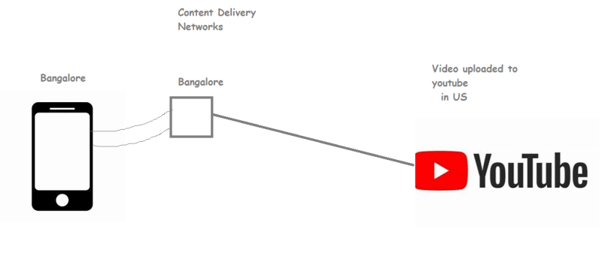

### Networking Foundations

#### **IP Addressing**

* This is used to uniquely identify a system connected to a network
* There are two popular Ip Addressing formats
  + IP Version 4
  + IP Version 6
* IP v4 address structure:
  + This a 32 bits divided into 4 eight bit Octet (group of eight)
  + IP v4 is represented in a format called as dot-decimal format
* Binary Value: 10101001.11100011.00011001.11011010
* Decimal value: 169.227.25.218
  + ip v4 addresses will be in the following range in dot decimal format
* 0.0.0.0 to 255.255.255.255
* Using IpV4 to create networks Classfull IP addressing was introduced 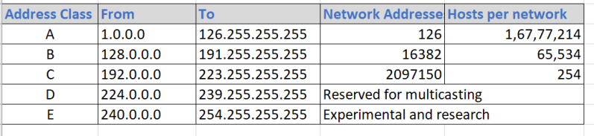
* IP Address: 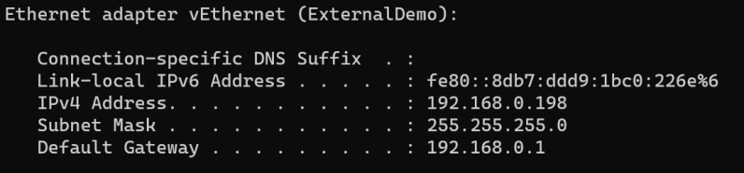
* IP Address is combination of two addresses network id and host id. Just by looking at ip address we cannot specify what is network id and what is host id

ip: 192.168.0.10

* To determine network id and host id we need subnet mask

ip: 192.168.0.10

sm: 255.255.0.0

nid: 192.168.0.0

hid: 0.10

network size => number of hosts that can be connected to this network

hid size => 2 octets => 16 bits => 2^16-2 (one for network id and one for broadcast address) => 65536-2 => 65534

ip: 10.11.25.10

sm: 255.255.255.0

nid: 10.11.25.0

hid: 10

network size => 1 octet => 2^8-2 => 254

ip: 172.16.0.9

sm: 255.255.255.0

nid: 172.16.0

hid: 9

network size=> 1 octet => 8 positions => 2^8-2 => 256-2 =>254

* If we follow this convention we have 3 possible networks

network 1 SM => 255.255.255.0 => Network size = 254

network2 SM => 255.255.0.0 => 65534

network 3 SM => 255.0.0.0 => 16777214

* Scenario: In my office network i want to connect 500 devices
  + So as per the above ip addressing you have to go with network 2 which is of size 65534 whereas we require only 500 devices
  + Other approach can be create two networks of size 254 each
* Now Lets under CIDR (Classless Interdomain routing) addressing scheme
* Till now we are looking at SM octets as decimal, if we start looking at SM as binary numbers

ip: 192.168.0.10

SM => 11111111.11111111.11111111.00000000

n/w size => 2^8-2 = 254

cidr => 192.168.0.10/24

ip: 192.168.0.10

SM => 11111111.11111111.11111110.00000000 => 255.255.254.0

n/w size => 2^9-2 => 512-2 => 510

cidr => 192.168.0.10/23

ip: 192.168.0.10

SM => 11111111.11111111.11111000.00000000 => 255.255.248.0

n/w size => 2^11-2 => 2048-2 => 2046

cidr => 192.168.0.10/21

ip: 192.168.34.193

SM: 255.255.255.240

SM: 11111111.11111111.11111111.11110000

n/w => 2^4-2 =>14

cidr: 192.168.34.193/28

* How does two systems in a network know that they belong to same network?
  + Two systems are considered to be in a same network when their n/w id is same 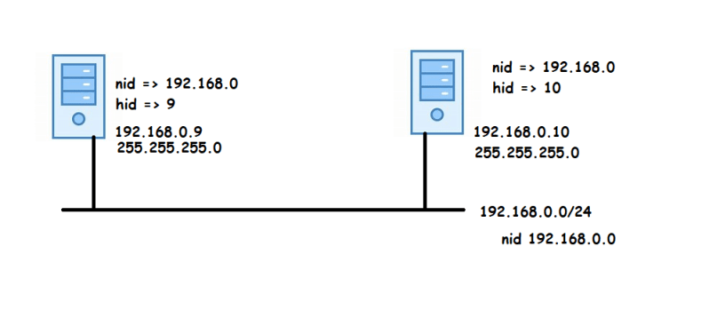
* Basic Networking rule: A system can communicate with other system in the same network. Network packets can travel only with in a network
* Two networks cannot communicate directly, we need a router to forward packets from one network to other 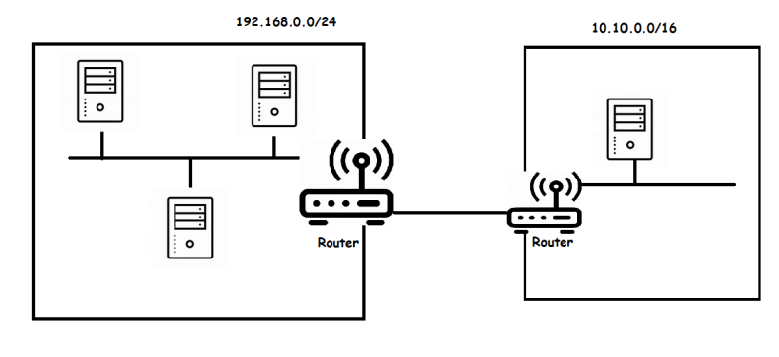
* In the ip config we have default gateway is ip address of router.

Subnetting

* A subnet is a logical segment of larger network & subnetting is a logical addressing technique that creates smaller subnets using existing IPV4 addreses 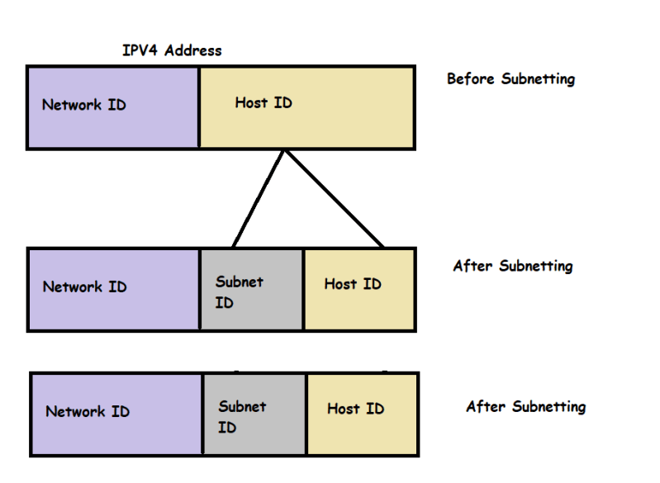
* Subnetting 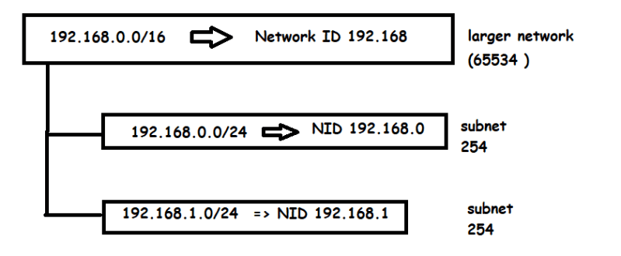
* Scenario: An organization has created a network for private usage [Refer Here](https://en.wikipedia.org/wiki/Private_network#Private_IPv4_addresses) the organizational network cidr range is 10.10.0.0/16
  + Now we are asked to create two subnets which can hold 500 devices
* subnet size should be ~= 500
* 2^n ~=500
* n => 9
* SM=> 11111111.11111111.11111110.00000000
* N/W Range => 10.10.0.0./16
* subnet1 =>10.10.0.0/23

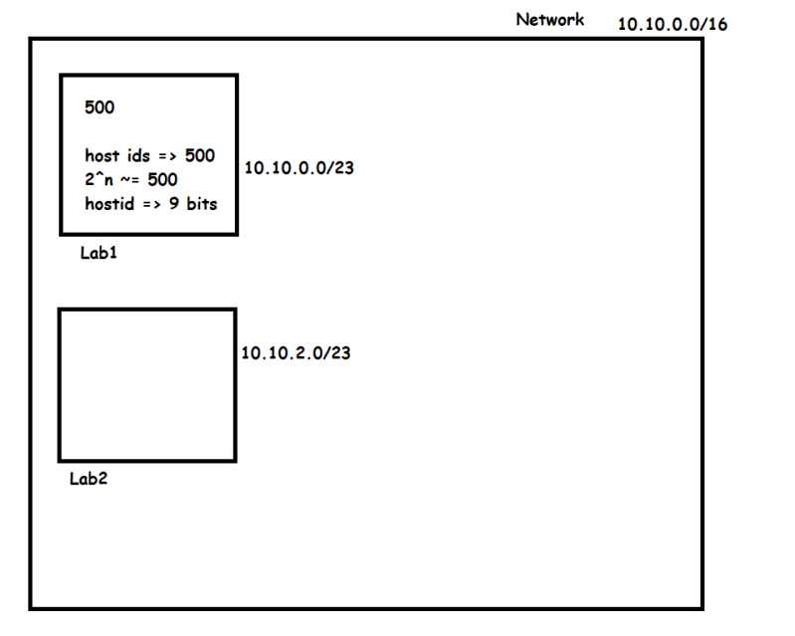

* Scenario 2: An Organization has a private network of range 172.16.0.0/16. We need to create 3 lab networks and each lab has 2000 devices

hosts => 2000

2^n ~= 2000

n=11

172.16.00000xxx.xxxxxxxx => 172.16.0.0/21

172.16.00001xxx.xxxxxxxx => 172.16.8.0/21

172.16.00010xxx.xxxxxxxx => 172.16.16.0/21

* Scenario 3: In your home you are create 3 smaller networks your network range for home 192.168.0.0/24. You need to create 3 subnets which can connect to 30 devices

number of devices = 30

2^n = 30

n =5

192.168.0.000xxxxx => 192.168.0.0/27

192.168.0.001xxxxx => 192.168.0.32/27

192.168.0.010xxxxx => 192.168.0.64/27